**MAHARASHTRA STATE BOARD OF TECHNICAL EDUCATION, MUMBAI**

Shri Vishweshwar Shikshan Prasarak Mandal’s

# Vishweshwarayya Abhiyantriki Padvika Mahavidyalaya, Almala

Certificate

This is to certify that, Mr. Akshay Dashrath Gitte, Mr. Harsh Moreshwar Kale and Mr. Sujit Sudhakar Sukane students of our institute from **Second** year **Computer Engineering (CO3I)** have successfully completed the micro project report on **“Program To Display A Moving Car”** of course **“Computer Graphics (22318)** as part of curriculum by the Maharashtra State Board of Technical Education , Mumbai.

For partial fulfillment of “**Diploma in Computer Engineering**” during the academic year 2022-23.

GUIDE HOD

Mr. Kazi A. S. M. Mr. Lokare A. P.

PRINCIPAL

Mr. Dharashive P.S

**MAHARASHTRA STATE BOARD OF TECHNICAL EDUCATION, MUMBAI**

Shri Vishweshwar Shikshan Prasarak Mandal’s

# Vishweshwarayya Abhiyantriki Padvika Mahavidyalaya,

Almala.

Micro-Project Report On

**“Program To Display A Moving Car”**

Submitted By

Enrollment No Name of Student

2110950049 Mr. Akshay Dashrath Gitte

2110950051 Mr. Harsh Moreshwar Kale

2110950159 Mr. Sujit Sudhakar Sukane

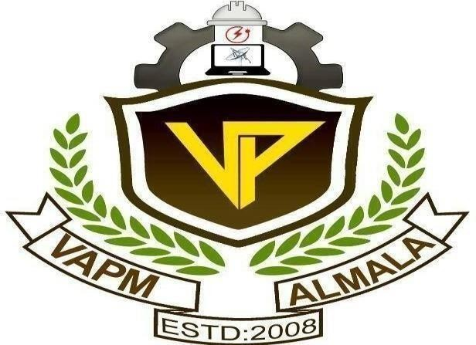Under the Guidance of Mr. Kazi A. S. M.

Department of Computer Engineering Academic Year-2022-23